How to set wireless mode for this router
Product line: Mobile Broadband Model number: 4G600/4G630
There are 3 working modes. This article will guide you how to set 4G600/4G630 as wireless router mode.
Note: Before setting 4G600/4G630, please make sure that you can access to internet when cable from modem is connected to computer directly.
Steps are as follow.
Part 1: Connect the devices
Part 2: Configure your computer
Part 3: Setup the router
Part 4: Check whether you can access internet

Connect the cable form modem with the WAN port of the router, then connect your computer with one of the LAN ports of the router by a cable.
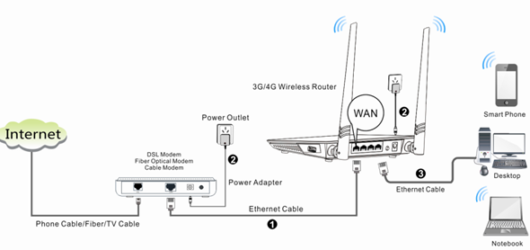
Note: after connection the SYS light should be blinking, the WiFi light should be on or blinking, the WAN light should be on or blinking.
1 Click on Network Connection Icon on the system bar, then click on Open Network and Sharing Center. (Here is for windows 7, other operating system please click HERE.)
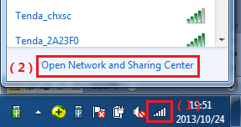
2 Click on Change adapter settings.
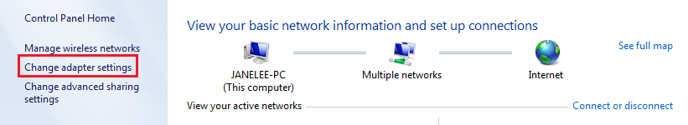
3 Right click on Local Area Connection, then choose Properties option.
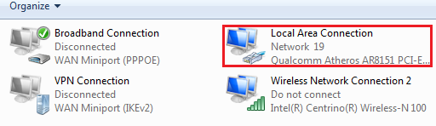
4 Double click on Internet Protocol Version 4(TCP/IPv4)
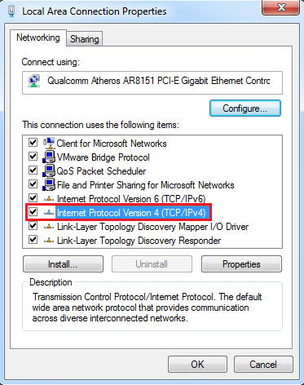
5 Choose Obtain an IP address automatically and Obtain DNS server address automatically and then click OK.
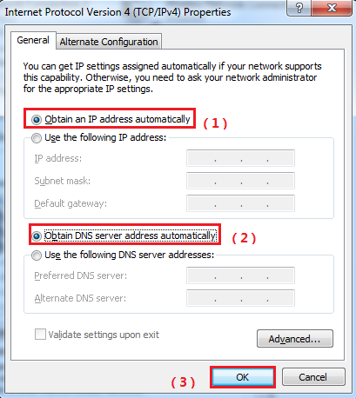
6 Also click on OK on the first Local Connection Properties window
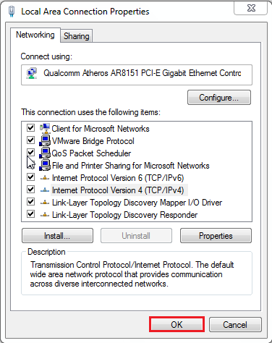
1 Open a browser then type 192.168.0.1 in the Address bar, click Enter.
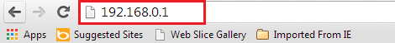
Note: if you cannot login the management page, please click HERE.
2 Type the Password in the bars then click on the Login button to login the setting page.
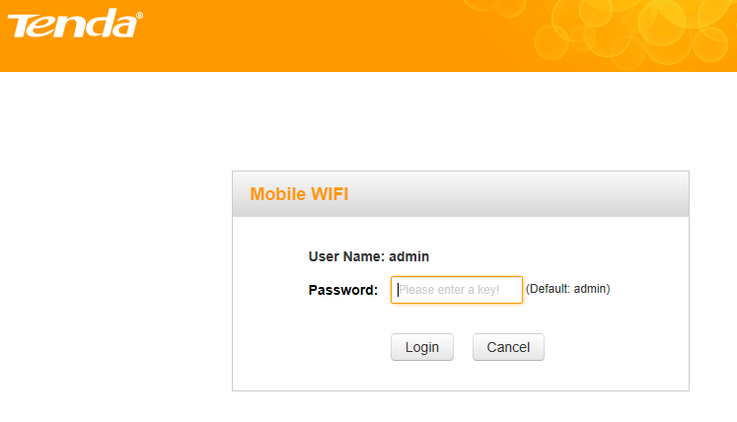
- Choose the Wireless Router Mode option, then click on Next.
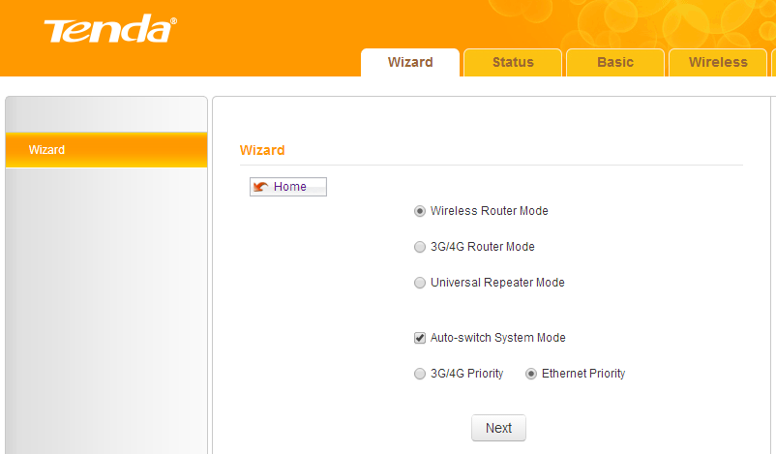
- Choose the correct internet connection type, if you are not sure which to select please ask your ISP for help.
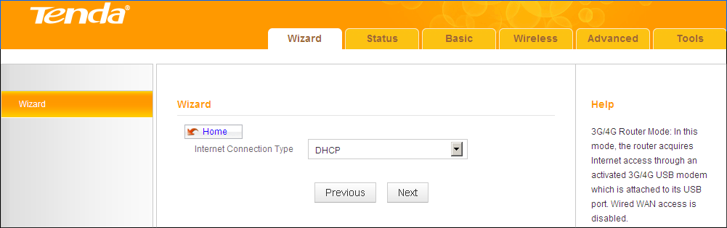
- Configure your wireless network: SSID, Channel, Key and then click Next.
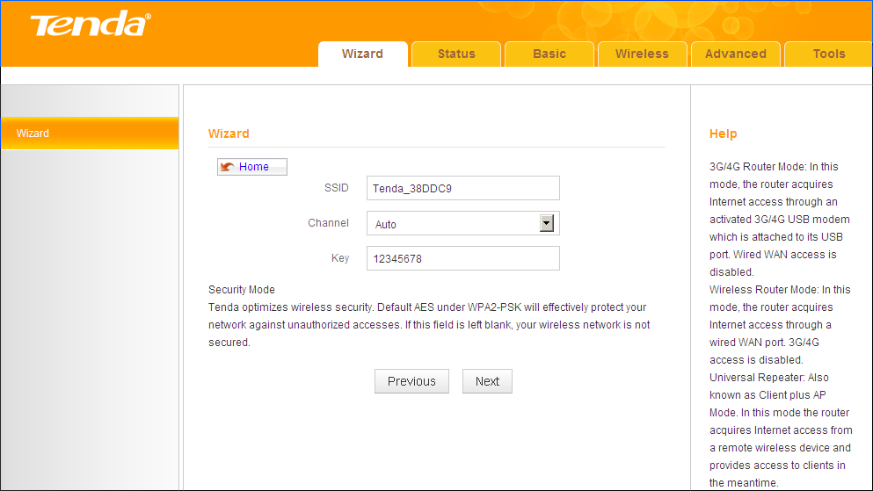
6 Click Finish and wait for the device to restart.
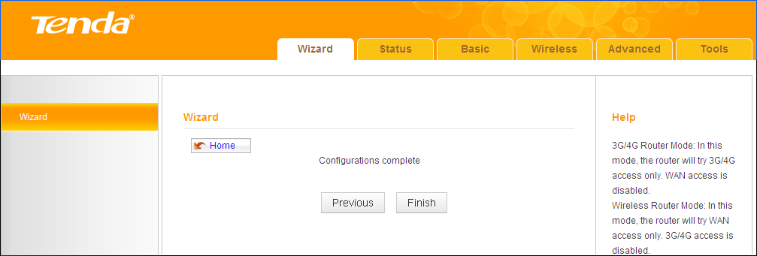
Type the Password as admin to login the setting page then click on Status to check the connection status of 4G600.If it shows connected then you can enjoy your internet.
